4/1/2026
Bug Slayers
Michael Fuentes, Christopher Ledford, Emirhan Tektas
EzPlay SYSTEM
REQUIREMENTS DOCUMENT

Table of Contents
Introduction 2
Description Model 3
Class Diagram 8
Use Case Diagram 9
Use Case Scenarios 9
System Sequence Charts 9

Introduction (ET)
This document details the system requirements for the EzPlay system and outlines the technical framework for all our features. The Description Model describes in detail the outputs, inputs, processes, performance, and security of each feature. The Class Diagram outlines the entities, methods, and relationships in the EzPlay system. The Use Case Diagram and Descriptions visualizes the use cases for EzPlay and then discusses the step-by-step process of each use case. The final System Sequence Diagram ties everything into a visual representation of the actors in each use case and the interactions they would have with the EzPlay system. These visual and descriptive models offer a deeper look into the system's architecture and the specific interactions between users and the EzPlay environment.

Description Model (CL)

General Functions
- Input
  - Mouse and keyboard input is read by EzPlay when logging in.
  - The user can send friend requests, which travel through EzPlay’s servers.
- Output
  - Once the user logs in, the PlayRoom screen is sent to the user by default
    - If the PlayRoom is not installed, it would be the DealPlay screen, and if that one is not installed it would be the CloudPlaylogged into is sent to the user. If none are installed, it would just open settings, where the user can install a feature.
  - The system will receive a user-sent friend request and send it to the proper account.
- Processes
  - Friends can be added by searching for their username. This friends list is stored and used for functions within features.
  - Each core feature, PlayRoom, DealPlay, and CloudGaming, can all be deleted or installed individually.
- Performance
  - Every account will have a linked username, email and password. While the email and passwords can both be changed, one email can only be linked to one account, the system will not permit two or more accounts to share the same email. The same goes for an account’s username, there will not be any username repeats allowed. The user can also change their username similarly to their email and password, however it can only be changed once every 24 hours.
    - Passwords can use any letter character, number character, with no special characters allowed (characters such as !@#$%^&*), and can be a minimum of 8 characters long with a maximum of 40 characters
  - Friend lists will not have a max friend count.
- Security
  - EzPlay information will be held in a database with AWS, protected through Amazon’s security.
  - Accounts will be protected with a simple login system, using an account’s email address and password to login. If a password is forgotten a request to change the password is sent to the email linked to the account.
  - There will be basic bot protection on the login screen through a CAPTCHA.

PlayRoom
- Input
  - Keyboard input is necessary to send messages.
  - Mouse left clicking is read when selecting a game.
  - Microphone input will be read when in a call.
    - This just refers from audio streaming when talking to others in the call, there will not be any audio commands.
- Output
  - Microphone input from others is sent to the user’s headphones as output.
  - Messages sent by other users will be displayed in a feed.
  - When a game is selected, EzPlay sends the game to the user as a new window.
- Processes
  - A group can be created where users can send messages, call, or play small games. Group invites can be sent through a username search or your friend list.
  - Messages can be sent and deleted.
  - Clipping can be done with a keyboard press
    - Clips will record the past 30 seconds prior to the clip keybind being pressed. The video file is then sent to a file within EzPlay’s download directory. In the PlayRoom, clips saved to this file can be modified to shorten clip length and then exported as a new video file under the MP4 file type. As it is exported to EzPlay’s download directory, this means it is now a file on the user’s computer. The user can do whatever they want with the clip, such as share it on social media.
  - Games can be selected and played, they will be kept very simple such as PONG or Hangman.
- Performance
  - PlayRoom games will be designed to hold 2-8 people.
  - A group in PlayRoom can hold a max of 32 people with a 500MB file size limit for sending attachment files (every file type is accepted). This includes videos or images, media is simply displayed as a downloadable file rather than displaying the video or image.
  - The FPS of a clip can be modified in PlayRoom settings, and can be set to 15, 30, and 60fps.
  - The resolution of a clip can be modified in PlayRoom settings. The resolution can be 480p, 720p, 1080p or 4k. Not all clips will be able to be uploaded in PlayRoom due to the file size limit and how much space a 4k or 1080p clip can take up, especially at 60fps.
  - Some parts of PlayRoom can be disabled. This includes games, messages, and the call feature. Disabling a feature essentially removes it as an element on the user’s installation of PlayRoom. These elements would still exist for others in PlayRoom, given they have not disabled these elements.
  - Games can be disabled in the PlayRoom settings. This makes it so the user will not see notices of a game being started, and would de-clutter the screen as the area of game selection would be a large UI element.
  - The message feed in general and the call feature can each be individually disabled. This does not disable these features globally in a group, but rather similarly to the game disabling it is just done individually on the user’s end. This can be done to optimize performance from the user’s system if one or the other is not needed for whatever reason.
  - Response on sending messages will be quick as well as response time within games.
- Security
  - EzPlay will request mic permissions from the user when a call is joined

DealPlay
- Input
  - Keyboard input is read when utilizing the search bar function.
  - When filtering results, mouse left click input is read as toggles are switched.
- Output
  - Following a search, a list of games is then displayed to the user with the results displaying titles close in name to what the user searched.
  - When a starred game goes on sale, EzPlay displays an alert to the user in the starred games area.
- Processes
  - The search bar will display prior searches, up to 5 prior searches.
  - The user will have the option to search for a game from a search bar. The results just include a list of the game names. When a game is selected from this list, information would pop out to the user, showing the storefronts a game is on, the base price of the game on its available storefronts, and the sale price of the game on each available storefront (if a game is not on sale on a specific platform, no sale price will be shown).
  - The user will have the option to filter search results.
  - The user will be able to star games, to quickly find out when and if they are on sale.
  - Games searched for frequently will automatically be displayed in a “Hot Deals” section when they are discounted by 35% or more.
- Performance
  - DealPlay will refresh once every 30 minutes to update deals.
  - Web storefronts where information is linked from would include the PS Store, Microsoft Store, Nintendo eShop, and Steam.
- Security
  - Store sites linked to DealPlay are manually picked, in order to prevent it from being filled with fake game listings from unofficial store sites.
  - If connection to a store site is temporarily down, DealPlay will continue to display the previously received deals, but with a warning message telling the user that the deal may be outdated.

CloudGaming
- Mixed Input/Output
  - In addition to keyboard and mouse, basic controllers will be supported and read as input.
    - Controller types would include PlayStation DualShock controllers, Xbox controllers, Nintendo Pro Controllers, and any other 3rd party controller (which are read as normal xbox controllers in Windows’s built-in controller settings).
  - When hosting a cloud gaming session, the host’s system effectively is reading the host’s own input as well as the input of the friend joining the session, both directly to the host’s system.
  - The user’s payment information must send a form of payment through credit/debit card or paypal.
  - A flag on the user’s account is flipped in order to indicate that their subscription service is now active once payment has been received and processed.
  - The streamed cloud game’s display from the EzPlay gaming servers is sent live to the users.
  - Users joining a gaming session send their input over to the host’s system.
    - With how streaming works, a joining user’s input is not actually read by the game on the joining user’s system, as the game is ran entirely on the host’s system, with the joining user connected through the cloud. This means when the joining user inputs anything, it is read through the cloud and received on the host’s system, where the input is repeated on the host’s system. This whole time, the game’s display is copied from the host’s system to the joining user’s system, making it seem as though the joining user is playing the game on their own system. This system of input/output is why CloudGaming has higher input-lag than normal gaming, and is also why a strong internet connection is required both ways.
  - Users utilizing EzPlay’s CloudGaming gaming servers send their own input over to the connected gaming servers, where it is then read locally.
- Processes
  - The user can use EzPlay’s CloudGaming service to run games through EzPlay’s gaming servers, which are then streamed to the user allowing them to play games which their own system is not strong enough to run.
  - The games available under EzPlay’s CloudGaming service are all displayed under a section called “Catalog”.
  - The owner of an EzPlay CloudGaming subscription service can host a gaming session, allowing friends who are not subscribed to also connect to EzPlay’s gaming servers and play with the host. This feature only works on multiplayer games.
  - If the user is not subscribed to the subscription service, or the user wishes to host a game not hosted on EzPlay’s gaming servers, the user to select a game of their choice to host for a multiplayer cloud gaming service. What this means is that the user will run the game locally from their system, while a friend connects to their system, treating the host’s system similarly to how they would have connected to EzPlay’s gaming servers.
  - When hosting a P2P session, a warning box is sent to the user describing the security risks of P2P connection (later explained in Security).
- Performance
  - An EzPlay CloudGaming subscription service must be subscribed to to host a gaming session as well as play games from EzPlay’s own CloudGaming system. These are the only functions locked behind the subscription service, and there are no tiers to the service.
  - It is recommended to have a 10 Mbps (megabytes per second) download and upload speed to run our cloud gaming service, whether it is playing singleplayer or joining another’s session hosted on our cloud gaming service.
  - When personally hosting a game session, it is also recommended to have at least 10 Mbps download and upload speed. Unlike when using our cloud gaming service, as a host your computer must also be strong enough to run whatever game you are hosting at a consistent rate.
  - When joining a game session, the same 10Mbps download/upload speed is recommended.
  - EzPlay gaming servers will have high enough specs to safely target 60fps at 4k in every game hosted from EzPlay.
  - Just like other Cloud Gaming services, EzPlay’s CloudGaming will have a slight input lag, higher than it would normally be if games were run natively from the user’s system. The input lag will be roughly 75 milliseconds, which may trend slightly upwards or downwards depending on the user’s connection strength to EzPlay’s gaming servers.
  - Self-hosting a gaming session is a process that is done through EzPlay linking an account to the host, but it does not use EzPlay’s gaming servers, instead it uses the host’s system as the base server. This means that the host will need a very strong system to support their own running of the game in addition to the other joining their game.
- Security
  - Using EzPlay’s cloud gaming service operates with a client-server relationship, with EzPlay’s security defending personal information such as your IP address. When joining another’s gaming session, Peer-to-peer is used instead, making your IP address vulnerable. As such, it should only be used with those you trust, such as close friends. When hosting a session, the one who joins is also able to send input directly to your system from their own output.
  - The user’s payment information is stored within EzPlay following the purchase of the subscription service, however the user has the option to remove their payment information following purchase of the service. This would cancel the service upon renewal date but it is also an option to ensure auto-renewal does not occur if the user is concerned about that.

Class Diagram (ET)
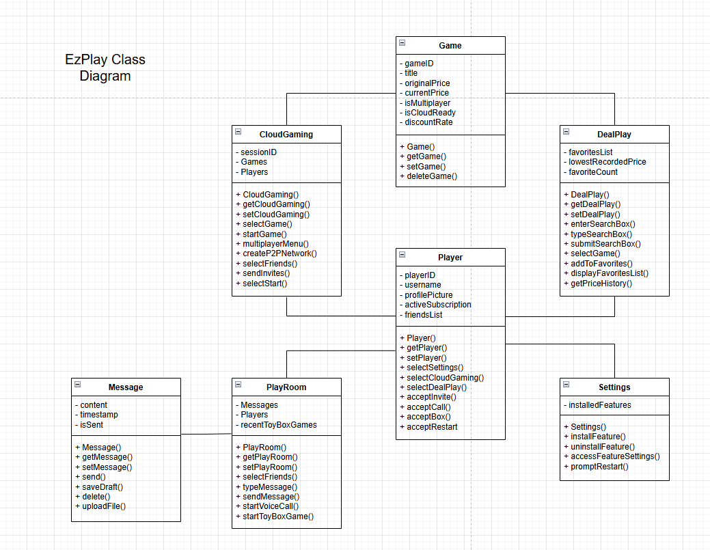
If Not Showing, See Additional Files

Use Case Diagram (MF)
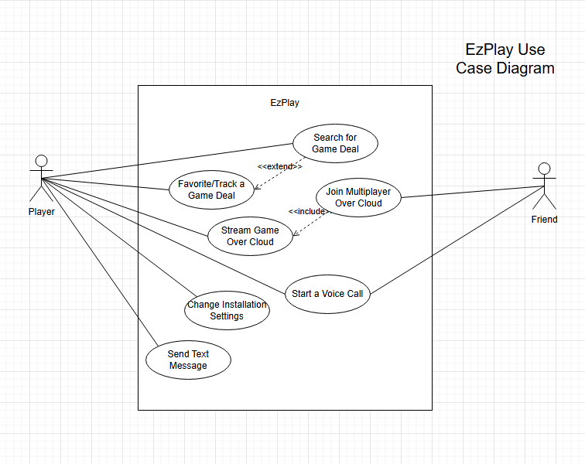
If Not Showing, See Additional Files

Use Case Scenarios (MF)
See Additional Files

System Sequence Charts (MF)
See Additional Files

